

Area Updates

November 2018

[](http://www.google.com/url?sa=i&rct=j&q=&esrc=s&source=images&cd=&cad=rja&uact=8&ved=0ahUKEwiMrqvb4o7WAhXIslQKHbuPCAUQjRwIBw&url=http://rosedale.bcps.org/student_support_services&psig=AFQjCNFjn9tz7oKYeiWqSasxSOMN3tEVIQ&ust=1504725596670977)

***Academic Achievement Center – Lindsay Laney:***

Nothing Reported.

***Admissions & Records Area Update – Lesley Michtavy:***

Nothing to report this month.

***Articulation Area Update – Elizabeth Pfleging:***

Nothing to report this month.

***CalWORKS/Job Placement/GED – Jill Olson:***

Nothing to report this month.

***Career/Transfer Center – Mike Igoe***

All 14 of our Transfer Day Universities joined us on November 8 for a lively event in Upper Manzanita, complete with eight back-to-back Transfer Workshops that were an additional highlight!

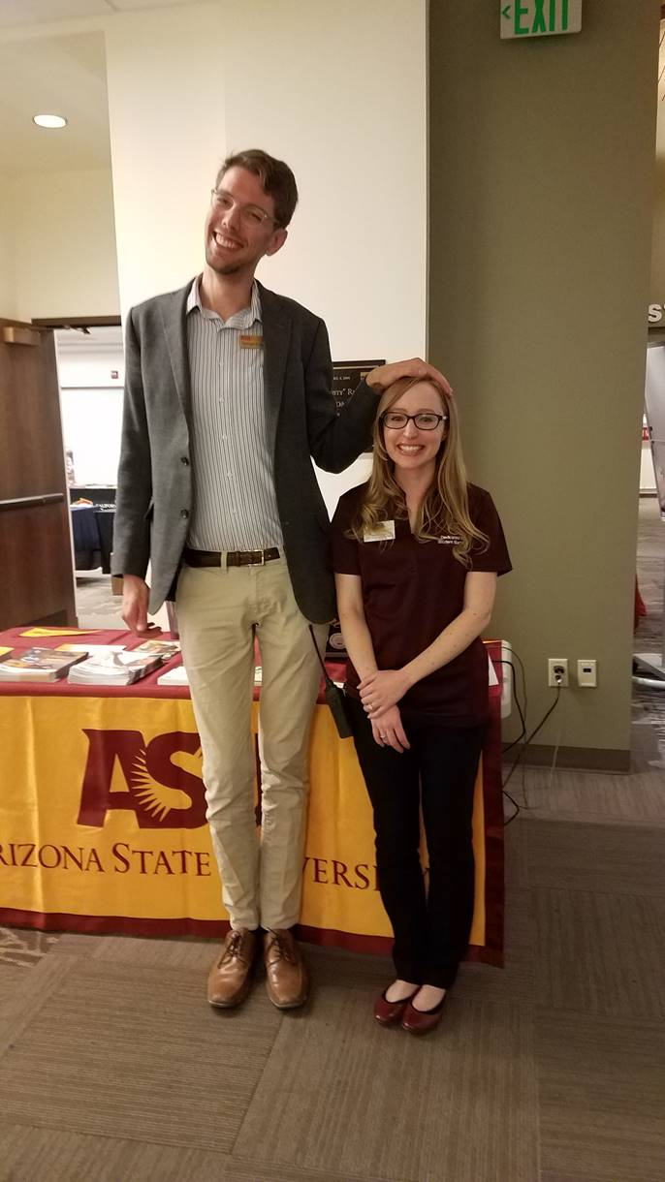

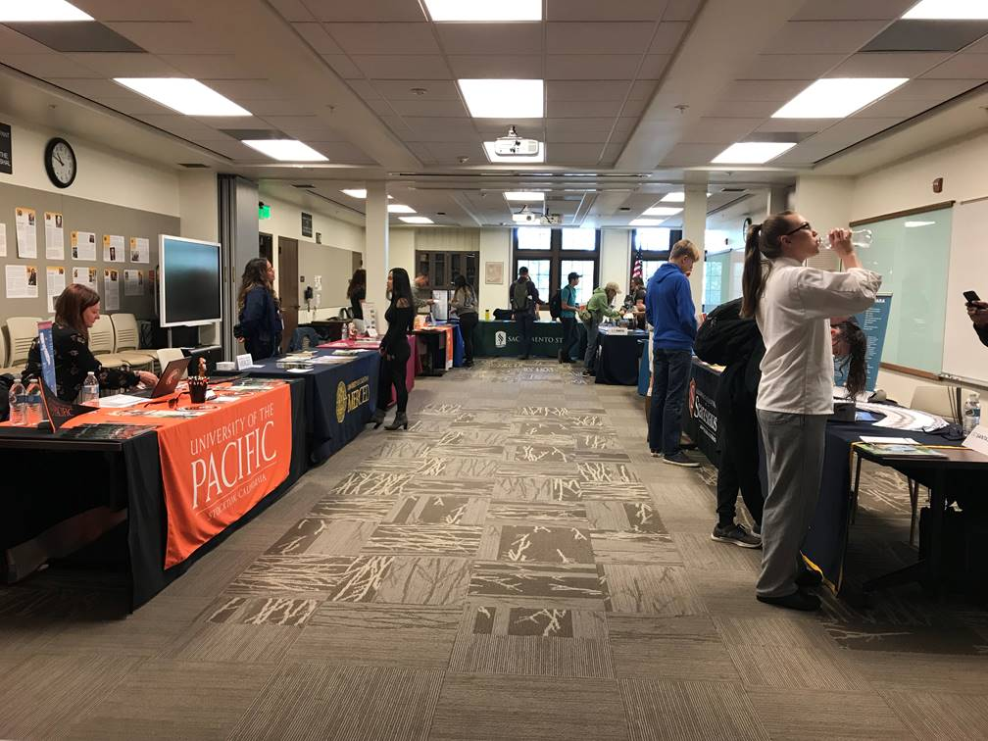

***Counseling Area Update – Elizabeth Pfleging:***

It’s go-time for our transfer-ready students as CSU and UC applications for Fall 2019 are due by November 30. We also spent a couple days out at Sonora High getting Middle College students ready for the spring semester and building interest for the CCAP Spring offerings out there. Application workshops for graduating seniors have started, and thanks in large part to the Promise Scholarship, Sonora High alone had 125 students sign up for the workshop!!! The Promise Scholarship application is live on [website](https://www.gocolumbia.edu/give_a_gift/columbiapromise.php) now.

A highlight in our case management system continues to be the positive response from students as we are able to say, “I will be your person.” HPMGT invited us to present a degree planner workshop for their very full Baking class, getting all of their student ed plans active in Starfish! We’ve also gotten to visit classrooms to introduce the program-specific counselor concept, and it has produced some great counseling connections. If you are interested in a counselor coming to your class, don’t hesitate to contact us!

## Starfish News

Come see how Starfish works, ask questions, and get help at our next Genius Bar on November 29, 11am-1pm in the Career Transfer Center.

Counselors are receiving further Starfish training this month, and we have a good group representing Columbia at a regional CCC users conference in December. We are working to gain more knowledge of how to best respond to flags, pull cohort data and leverage degree planner tools.

Kirsten and Mike presented Starfish with Melissa Colon’s online EDUC 50 class on November 5, which was a recorded session. If you are interested in viewing it, contact Melissa Colon!

We have known that our data has been cluttered for some time in Colleague… and Starfish is making it very apparent! This is good news and bad… the good being that we can start cleaning it up and make sure we have correct and recent information on students, as well as examining processes to keep it clean moving forward. The bad is weeding through it all and maybe not being able to get accurate data in the mean time! Getting this right is going to be what makes Starfish a powerful tool for students and staff alike… so the more we look at it, use it and make corrections, the better it will become. Please send any Starfish questions or updates you have to Melissa Raby.

***DSPS Area Update – Sean Osborn:***

In October, DSPS held a priority registration event to help students who have priority registration be able to enroll in their classes. We were able to assist 24 students all of whom enrolled in Spring 19 classes. We continue to make changes to the DSPS program that continue to streamline our services. We will also be starting a small facelift to the High Tech Center, in an effort to provide more useful information to all participants who utilize this facility.



***EOPS Area Update – Matt Fox:***

Matt and Sunny had their long-awaited, beautiful baby girl, Sierra, on Sunday, November 4, at 10:23a. She weighed in at 6 lbs. 9 ozs. and the whole family is doing great. Isn’t she precious!!

***Financial Aid Area Update – Marnie Shively:***

Nothing to report.

***Foster Kinship & Care Education – Danielle Brouillette:***

The last month I have been working diligently with the three counties Columbia College serves (Tuolumne, Calaveras, and Mariposa) to set up the next 8 months with a plethora of training opportunities for the caregivers and have added training support.

I am proud that all three counties are doing a great job with the pre-approval trainings (state mandated 12 hrs. of training to be pre-approved before receiving a license to be a foster/adopted caregiver) and updated curriculum, as they are tailoring it to meet their unique county’s needs. I would like to see more training opportunities to bring resource families together after their mandated training is completed. Therefore, I have hired Rebekah Sandlin (she was in this positon prior to me) to help support counties in implementing ways to get more caregivers to in-service trainings. All caregivers have to obtain 8 hours of training each year to stay licensed. My overall goal is to have more great caregivers to provide excellent care to our foster youth. If the caregivers we currently have are better trained and offered more training opportunities and feel supported, more great caregivers will jump on board!

***Foster Youth Area Update – Stephanie Beaver:***

Nothing reported.

***Health Services Area Update – Laureen Campana:***

Nothing reported.

***Library Area Update – Brian Greene:***

Food for Fines - Throughout November the library is running its annual Food for Fines event where we accept food donations to pay off library fines. One food item earns a $1 credit, which is a good way for students to clear up any balances and contribute to a good cause. This year the food we collect will go to a Child Development Club project as well as local charities.

History Databases - The library has arranged extended trial subscriptions to several history-related databases from Infobase publishing, including American Indian History, Ancient and Medieval History and African-American History. Find links from the Articles & Databases page of the library’s website and try them out today!

***Mental Health Services – Tamara Oxford:***

**Mental Health First Aid Training:**  Save the Date in Spring Semester.   **Thursday 3/21/19 from 1 – 5 p.m. and resuming Friday 3/22/19 from 8:30 am. to 12:30 .** We will be hosting a Mental Health First Aid Training (MHFA) for no cost/on campus.  (It is an 8 hr training and you must attend both parts.) Sign-ups will begin soon.  It will be open to the public, but our goal is to fill it with campus employees and students. (Consider your student workers!)  It is very helpful Mental Health training to assess, assist and refer on a spectrum of mental health issues.  It also helps de-stigmatize mental health.   Mental Health and Wellness has been linked to student success.

**Winter Wellness Event**:  Save the Date:  Feb. 14, 2019 will be “***Gratitude Day”***.  Remember the spirit of “Love is Louder” on Valentine’s day a couple of years ago?  It was warm, engaging, nurturing, and connecting in the middle of winter.  Research demonstrates that practices of gratitude increase feelings of well-being and even happiness AND it reduces anxiety and stress.   Please consider using this opportunity to have an outreach table with an ACTIVITY that is related to Gratitude.  Think fun, or just come by for treats! It will be in Manzanita, exact location to be announced.

**LGBTQ+ Support Group**:  Please help get the word out to students (or employees) that we have a Peer Specialist from TC Behavioral Health on campus once a week to support this population with ANY issues in an ongoing support group.  This semester the group is meeting from 1 to 2 p.m. in Pinyon on Wednesdays.  It will continue next semester (perhaps with a time change).  Research shows that the LGBTQ+ population are a greater risk for stigma, discrimination, stress, and suicidal thoughts and feelings.  Help keep our campus safe by getting the word out!

***Outreach/Student Development - Mike Igoe/Doralyn Foletti:***

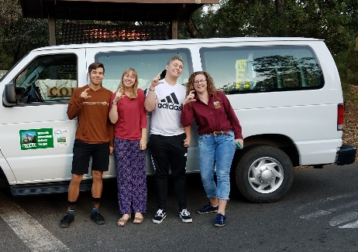**ASCC Travel:** Columbia College’s ASCC hits the road to Los Angeles to take part in the Annual California Community College Student Affairs Association Conference. Students had an opportunity attend a number of breakout sessions and network with students in leadership from across the state. ASCC sponsored a Student Forum RE: the YCCD Negotiations process. Dr. B was available to address many questions and concerns. The Food Bank has been very busy accepting new applications daily. October also saw the arrival of the first annual Pumpkin Harvest Event. Students took part in games and enjoyed a wide selection of snacks while promoting Midterm Madness that was held on October 25. ASCC kick off started November with free viewing of the film ***RBG***. The documentary celebrates the life of a legal and cultural icon, Supreme Court Justice Ruth Bader Ginsburg.

**A close up of a box

Description generated with high confidenceA close up of a device

Description generated with very high confidenceHydration Stations:** ASCC also heard the voices of the students they represent and addressed the lack of outdoor hydration stations on campus. The ASCC has moved to purchase one outdoor, ADC-compliant station to be located at the Student Center and one hydration station will be placed in the Oak pavilion. As they move into November, the ASCC is planning for the Annual Christmas Giving Tree, Children’s Christmas party, and Cram Night which will be held on November 29, 6-9p.

**New Student Ambassador:** Hello! My name is Halley Ellard. I have been at Columbia College for three semesters now; I originally started in August 2015 right after graduating high school. I have lived in Angels Camp for most of my life, but I plan to transfer to Oregon in the near future. My academic goals as of now are to finish all of my pre-requisites to get into a medical assistant program, as well as my attaining my Associates Degree. This is my first time as a Student Ambassador, but I am really enjoying the experience and getting to know all of you!

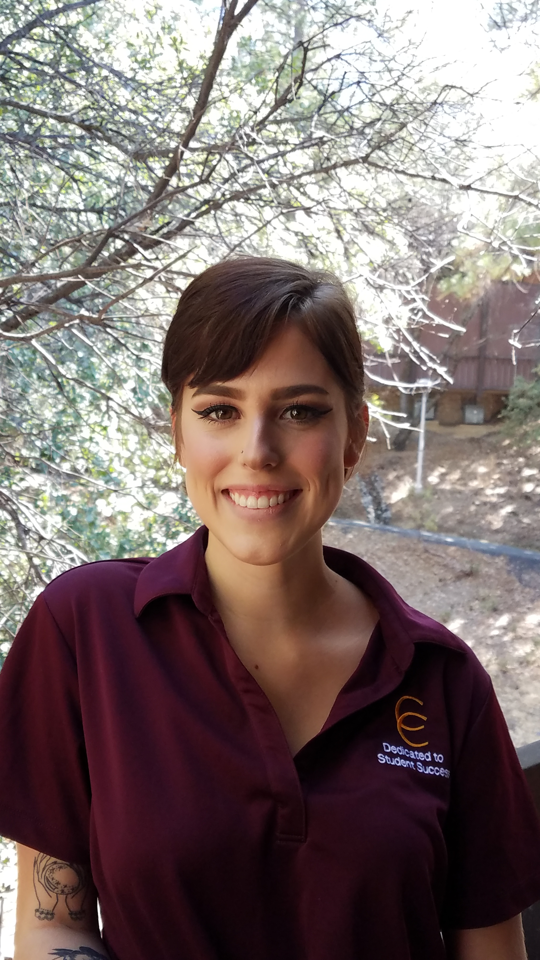

***TRiO: SSS & MEOC – Anneka Rogers Whitmer:***

**TRiO**:

Nothing Reported.

**MEOC:**

Nothing Reported.