**Columbia College Self-Guided Campus Tour**

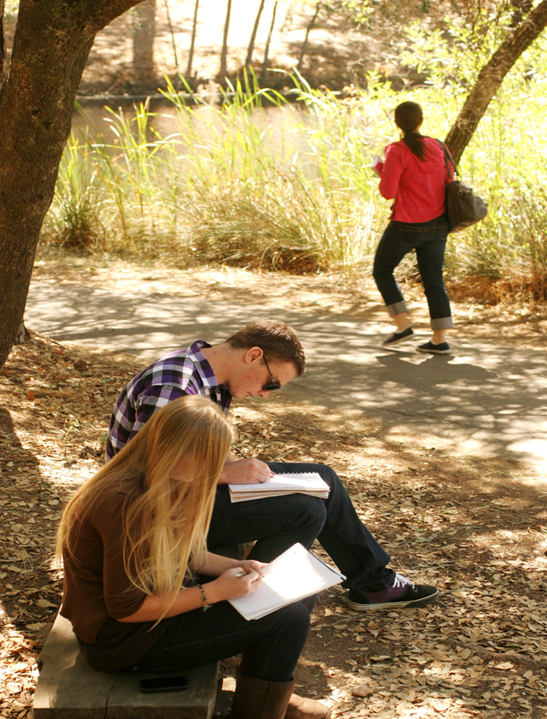

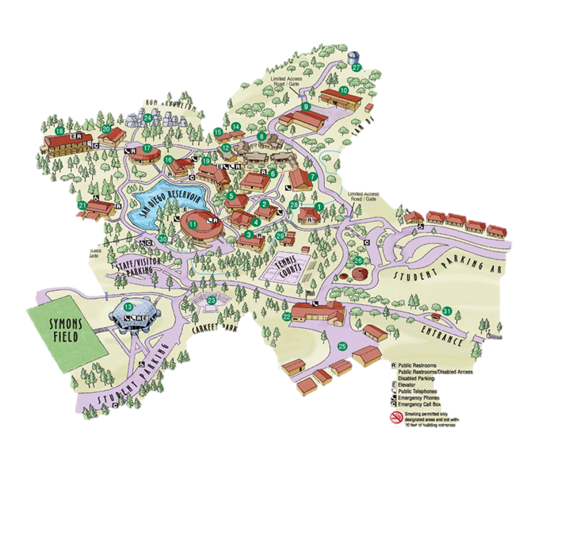

**Columbia College**

**Self-Guided Campus Tour**

**W**elcome to Columbia College! Located on 280 acres of forestland in California's historic Mother Lode, our college campus surrounds a peaceful four-and-a-half acre lake and has been described as one of the state’s most beautiful community colleges. Columbia College institutions of higher education affiliated with the Yosemite Community College District (YCCD). YCCD is *geographically* one of the largest community college districts in California with 4,000 square miles from San Joaquin Valley, Cost Range to the west to the Sierra Nevada on to the east.

As you take our self-guided, walking tour, you might see some, deer, squirrels, ducks and geese along the way. Efforts are continually made to maintain the grounds in its natural state. Enjoy!

1) **Alder–** Was once the original college gym on the second floor and used for Health & Human Performance Classes. Today, Alder is no longer used as an educational facility.

2) **Aspen**-Large, spacious classroom for music instruction and other course.

3) **Buckeye**-Combination classroom and Business Administration/Office Technology computer lab provide training for business and occupational skills

4) **Cedar**-General studies classrooms and faculty offices.

5) **Dogwood-**Also known as the Forum Building, doubles as a classroom and performing arts theater with 182 seats.

6) **Fir**-Houses the college Computer Information System’s lab.

7) **Juniper-**College Nurse Office and the Columbia College Entrepreneurship Program. This program can help provide the important background and training need to become a successful entrepreneur.

8) **Laurel** **- Child Development Facility,** A village of 5 buildings. The new center is nestled under existing oaks, manzanita and pines. The complex includes 2 adult classrooms, 2 infant classrooms, 2 toddler classrooms, 2 preschool classrooms and outdoor learning classrooms are is attached. Administration building and offices are on site. Laurel provides natural play-scapes which provide children with an optimal outdoor learning experience.

9) **Madrone-**Classrooms area and practical work lab for Automotive Technology.

10) **Mahogany-**Classrooms area and practical work lab for Welding Technology.

11) **Manzanita-**This 30,000sq.ft. Building was the first completed structure on our campus. It is the college’s central administrative hub. Among the many offices located here are the President’s Office, Vice President’s & Dean’s and the Columbia College Foundation. Other services: Admissions & Records, Business Office, Counseling, and Transfer Center, Financial Aid, Veterans Services, EOPS, DSPS, TRiO, Student Learning Offices, Bookstore, Snack Bar, Hospitality Management, Bakery, The Cellar Restaurant and the Instructional materials Center and mail room. The Rotunda area is used for exhibits, displays and public events.

12) **Maple –**General classroom and Child Development lab.

13) **Oak Pavilion**-Built in 1990, the Oak Pavilion is the Columbia College Sports Center and home to the Columbia **Co**llege Claim Jumpers Men’s Basketball and the Women’s Volleyball teams. The Pavilion is a 50,000 square foot facility which seats 1,400. On the lower floor there are classrooms, offices, male and female locker rooms along with an exercise room for Cardiac Rehabilitation, Adaptive PE and Adult Fitness. The second level has a state- or-the-art weight room, cardio exercise room and an indoor track.

14) **Pinyon** – Future location of the campus Nurse and Mental Health Office.

**15) Ponderosa**-The Student Center serves as the social, cultural and recreational center for Columbia College. The Center creates a welcome atmosphere for students as well as visitors. It provides opportunities for participation in educational, cultural, and recreational activities and provides services for the convenience of the campus community.

16) **Redbud** - General classrooms and nursing labs.

17) **Sequoia –** Math instruction / Math lab / faculty offices.

18) **Sugar Pine -**Named after largest species of pine, the Sugar Pine is the home Science & Natural Resource. The two-story 33,661 sq. ft. building is a model of green design and sustainable architecture earning a Gold classification in Leadership in Energy and Environmental Design (LEED). The integrated Science and Natural Resources building is home to the following disciplines: Chemistry, Biology, Physics, Anatomy, Zoology, Earth Science and Forestry Geology and Geographic Information Systems (GIS). Geo thermal is used to heat and cool the cadaver room. Currently, on display in various rooms are a number whole taxidermy specimens of native wildlife such as coyote, mountain lion, owls, raccoon, snakes, rabbits, turkeys, skunk, ducks, fox and bear. Partial mounts include: elk, moose, others. These native California animals were donated to the college’s Natural Resources Department over the years by private parties or The Department of Fish and Games from illegal poaching or accidental death.

19) **Tamarack Hall-**This two-story, 20,021 square foot facility is home to the college Library and the Academic Achievement Center (tutoring center) and faculty offices.

**20) Toyon-**General classes are held here. The tree round outside of the building is a nearly 600-year-old Sugar Pine.

21) **Willow-** overlooks the San Diego Reservoir and is home to the Columbia College Creative Arts Department.

22) **Public Safety Building-**The Public Safety Building is home to Fire Station 49 and the Public Safety Center (Campus Security) “Combining fire service and security staff into one location…enhance[ing] the response time for emergencies on campus and within the community”. Through a cooperative agreement with the California Department of Forestry and the Tuolumne County Fire Department, Columbia College’s Facility is an actual operating fire station that responds to fire calls; one of only two in the state, which is located on a community college campus and staffed by Fire Tech students and complete with full male and female living quarters, study room, kitchen etc. This excellent training program is the primary reason why so many of our college’s Fire Science Program graduates are in demand throughout the state.

23) **Charles Segerstrom, Jr. Memorial Amphitheater**-Performing arts and Public Ceremonies are conducted in this impressive outdoor facility.

24) **Segerstrom Arboretum Nature Trail** - A delightful quarter-mile trek through the woods to the campus arboretum, which contains rocky remnants of the former days of hydraulic mining in the area.

25) **Warehouse, Shipping/Receiving, Transportation& Maintenance.**

26) **Me-Wuk Cultural Center–** Includes a reconstructed roundhouse, sweat house, bark dwelling, acorn granary and grinding rock to reflect the local Sierra Me-Wuk heritage**.**

27) **Observatory-**Open only for college classes, several telescopes are available for students to observe planets, as well as deep sky objects and galaxies from the foothills.

28) **Par course-**Starting at the Alder Building, the extensive Fitness Jogging, and Trail is equipped with a Par Course. The Challenge Course winds around the campus for about 1 ½ miles along the ditch bank with 18 exercise stations.

29) **Davis cabin-**In exchange for the sale of the land terms included construction of a home for the previous land owner, “Billy Goat” Davis, which is the structure near the tennis courts. (His home was the first building on the Columbia Campus). The original Davis cabin was located where the Manzanita Building stands today. Davis held a claim on the land from the BML and when the college acquired the property.

**Other Points of Interest**

**San Diego Reservoir-**The San Diego Reservoir is a 4 ½ acre lake. The reservoir is a historical remnant from the early days of Hydraulic mining in the Columbia area—1850s. Prior to the opening of the campus, the lake was dredged and the island built in the center to attract wildlife. Since then, the lake has become the home of many varieties of ducks, Canadian Geese and 2 species of turtles. At one time the reservoir water was used as the campus drinking water…but no longer. It is 22 feet deep at its deepest point with an average depth of 4-6 feet…it is stocked with bass, crappie and sunfish. Fishing is not allowed but Columbia does offer a fishing class of catch and release.

**Tennis Courts**-Six (6) tennis courts are equipped with lighting and open to the public. Tennis classes are also part of the Columbia College curriculum.

**Symons Field-Located-** just behind the Oak Pavilion is a 100,000 square foot field for intramural soccer, softball and other Health & Human Performance classes.

**Carkeet Park -**Judge Ross Carkeet Community Park has picnic tables and open seating. Many outdoor events are held here: BBQs and Earth Day events. The general public can use the park as well. (Must reserve the location)



11600 Columbia College Drive, Sonora, CA 95370

**www.gocolumbia.edu**

General Phone Exchange **209-588-5100**

Admissions & Records **209-588-5231**

Counseling Office **209-588-5109**