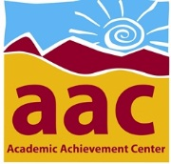
Academic Achievement Center (AAC)
Tutoring Referral
Free tutoring services are available to all Columbia students with the completion of a Tutoring Referral form each semester. Please ask your instructor or counselor to complete this referral and bring it to the AAC to make a tutoring appointment.

I recommend that the student named below receive tutoring for ________________________
to address the following learning needs: (choose at least one) ^{(course name)}

□ Study Skills □ Learning Strategies □ Reading Strategies

□ Math Proficiency □ Research Skills □ Test Taking Strategies

□ Writing Proficiency (includes AAC Stamp) □ Course Specific Review/Problem-solving

□ Other_________________________________________________________________

Student Name ____________________________________

Referring Faculty (Print & Sign) ____________________________________

Semester Year ____________________________________
Academic Achievement Center 588-5088 Tamarack 2nd Floor

